# File permissions in Linux

## Project description

This project aimed to demonstrate the ability to change file and directory permissions within the Linux. To achieve this, we can use a number of Commands within the CLI:

Chmod: Changes the permissions of directories or files within the CLI.

ls -la lists all the files or subdirectories within a directory. (Useful when trying to locate hidden files.)

cd: allows you to change the directory you are in.

pwd: Useful as a check in order to relocate the user with the directory and subdirectories they are currently in.

## Check file and directory details

## 

## Describe the permissions string

The permissions string, as seen above is a set of characters that denote the permissions that different users have in a file or directory. In Linux, these are displayed as ‘d’ for directory or a dash to denote a file. The characters and dashes that follow, denote who, or what has permissions over the file or directory. It displays in descending order from left to right in terms of User, Group or Other. For example drwx - - r - - - means that when one is looking at this example directory, the User has read, write and execute permissions for the directory, the group only has read permissions and the other has no permissions for this directory. Where an individual falls within these user permissions will determine if they are able to access certain files, directories and make amendments to them or not.

## Change file permissions

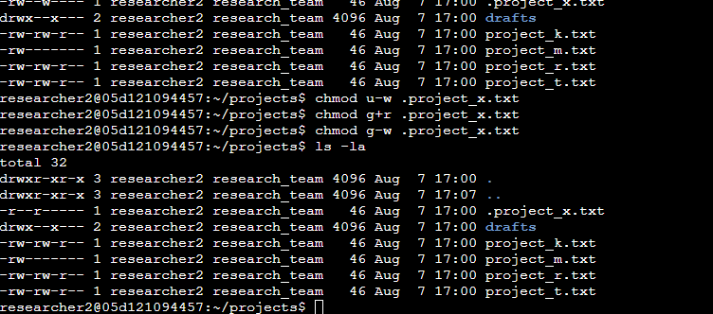

## Change file permissions on a hidden file

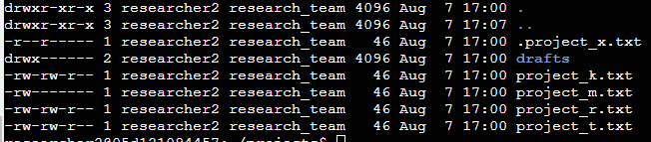

## Change directory permissions

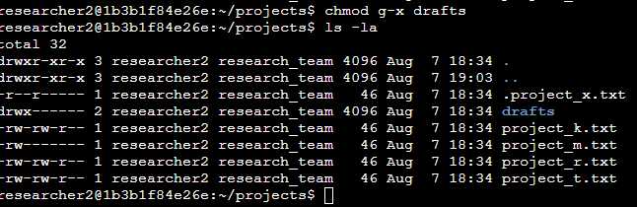

## Summary

The idea of changing permissions does not just relate to files on their own. You could, just as easily change the permissions of entire directories. This is vital for security and Cybersecurity professionals. Adherence to correct permissions within directories and on files is vital for Identity Access Management and some security principles like Least Privilege. Knowing how to change file and directory permissions when needed is an important aspect to security and information management.